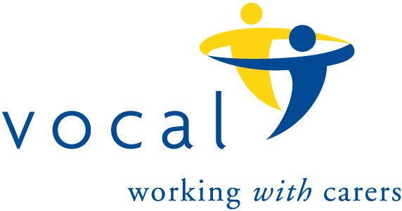The 100 Club

*Prize Draw number 148*

*Results for July, 2024 draw.*

|  |  |  |
| --- | --- | --- |
|  | *Name* | *Winning Number* |
| 1st Prize | *Elizabeth Robb* | *25* |
| 2nd Prize | *Eileen Vance* | *61* |
| 3rd Prize | *Aileen Harris* | *16* |
| 3rd Prize | *Gwen Wightman* | *58* |
| 3rd Prize | *Christina Winton* | *47* |
| 3rd Prize | *Catherine Owens* | *24* |