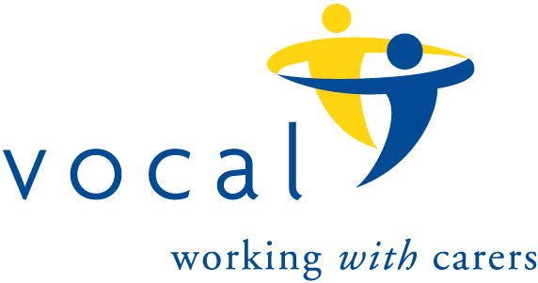
The 100 Club
Prize Draw number 141
Results for December, 2023 draw.

 | Name | Winning Number
1st Prize | Mary Lowrie | 79
2nd Prize | Martin Dunn | 86
3rd Prize | Agnes Cowan | 109
4th Prize | Ann Anderson | 37
5th Prize | Mark Hewitt | 50
6th Prize | Carole Jackson | 108

