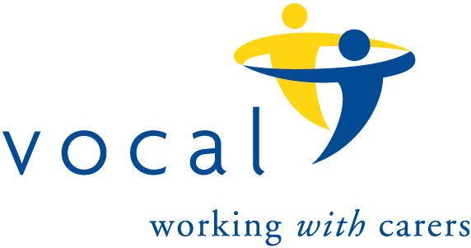
The 100 Club
Prize Draw number 140
Results for November, 2023 draw.

 | Name | Winning Number
1st Prize | Gwen Wightman | 58
2nd Prize | Charles Dennis | 56
3rd Prize | Eleanor Murray | 13
4th Prize | Jill Whitfield | 14
5th Prize | Arnot McDonald | 20
6th Prize | Elizabeth McKibben | 17

