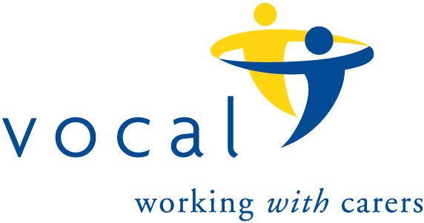
The 100 Club
Prize Draw Number 136
Results for July, 2023 draw.

 | Name | Winning Number
1st Prize | Charlotte McKay | 32
2nd Prize | Elizabeth McKendrick | 70
3rd Prize | Charles Dennis | 56
4th Prize | Eleanor Murray | 12
5th Prize | Sheila Turner | 35
6th Prize | Angela Bassi | 84

