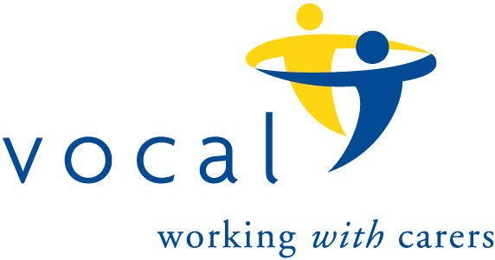
The 100 Club
Prize Draw Number 124
Results for July, 2022 draw.

 | Name | Winning Number
1st Prize | Eleanor Murray | 12
2nd Prize | Eileen Dickie | 28
3rd Prize | Thomas Gracie | 106
4th Prize | Angela Bassi | 85
5th Prize | Rosie McLoughlin | 78
6th Prize | Margaret Skilling | 30

