ROOM HIRE BOOKING FORM
Please complete the details below and return to Pauline Quinn by email: pquinn@vocal.org.uk or post to: 30/1 Hardengreen Estate, Dalhousie Road, Dalkeith, EH22 3NX.

Booking Details
Name |  | Organisation
Date & Time  room is required |  | Number of expected participants
Event type  (training, meeting, counselling etc.) |  | Room required & layout (i.e. Board, group tables, seating only) * | Room -  Layout -
*please see photos on reverse for guide to room layout

Booking requirements – please tick
Laptop |  |  | Flip Chart, pad & pens
SMART Board |  |  | Tea, Coffee & Milk **
Other (please specify)
** <5 participants: use of staff kitchen/tea prep area available for refreshments
6+ participants: when booking our Esk training/meeting room and refreshments are requested, we will charge £1/head for the expected number of participants.
Contact Details
Address
Postcode |  | Telephone
Email

Payment Details – please indicate which hire rate you require (room(s)/layouts overleaf)
Esk (training room)  Mon-Fri 9am-5pm £12.50/hr |  | Esk (training room)  Weekends & Evenings £15.00/hr ***
Vogrie, Fala & Caerketton (meeting rooms)  Mon-Fri 9am-5pm £10/hr |  | Vogrie, Fala & Caerketton (meeting rooms)  Weekends & evenings £12/hr
One-off full day(8hrs) booking – 10% discount |  | Ongoing (minimum of 4) full day (8hrs) bookings – 20% discount
Total Cost

Invoice to
Address
Telephone |  |  | Email
***key access is provided for bookings outside office hours.
Confirmation
I confirm that I have read and accept VOCAL’s Room Hire Terms & Conditions.
Signed |  | Print |  | Date

Esk  Purpose: Board Meetings, Training  Capacity: 16-20 (depending on layout)  Equipment: Laptop & Smart Board  Flip chart also available on request. | 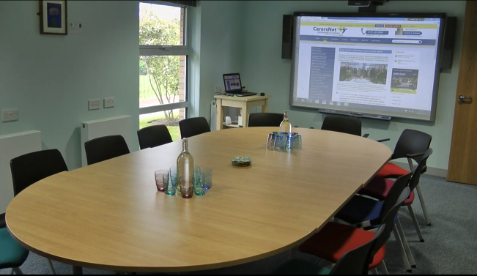  Board Layout
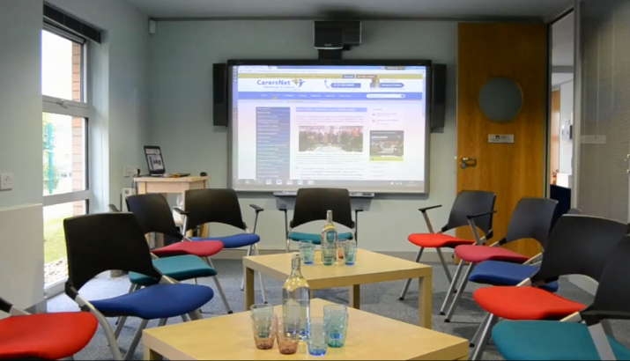  Group Layout | 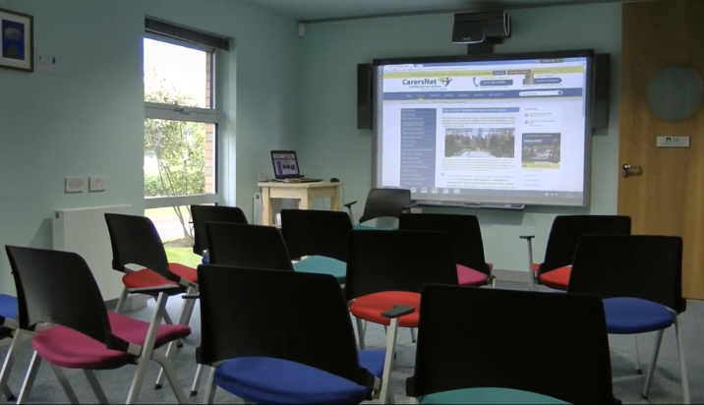  Lecture/Training Layout
Vogrie  (secure access)  Purpose: Counselling, Interviews, Focus groups  Capacity: Interview layout – 6 max  Counselling layout – 3 max  Small group layout – 3-6 max | 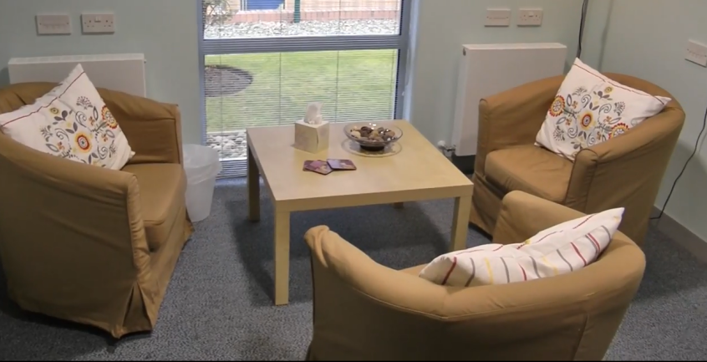
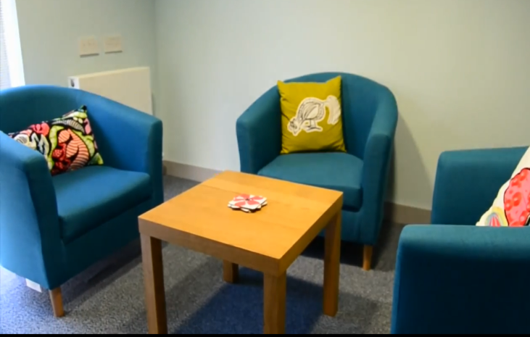 | Fala  Purpose: Surgeries, carer meetings  Capacity: 3-4 max  This room is furnished with three comfy chairs around a small coffee table but also has a small writing table with 2-3 chairs available.
Caerketton  Purpose: Surgeries, carer meetings  Capacity: 3-4 max  This room is furnished with three comfy chairs around a small coffee table but also has a small writing table with 2-3 chairs available. | 